Origami For All
Paper Folding

4thDecember 2025

PREPARED BY

M.RAFAY FAROOQ

S.no | Student id | Name | Email
1 | 1572806 | Mr. M. Rafay Farooq | Rafayfarooq376@gmail.com


Table of Contents
4thDecember 2025
PREPARED BY 1
M.RAFAY FAROOQ 1
4
Background and Necessity for the Web Application 4
Origami, the traditional art of paper folding, has gained popularity among learners of all ages due to its creativity and simplicity. Traditionally, people relied on books or in-person guidance, which limited access to proper instructions. With growing interest, users now prefer online platforms that offer organized tutorials and easy navigation. A dedicated origami website helps learners explore designs according to their skill level. It also provides a convenient digital space where users can learn step-by-step folds anytime and anywhere. 4
Proposed Solution 4
Purpose of the Document 4
Scope of the Project 5
Constraints 5
1.6 Functional Requirements 6

Background and Necessity for the Web Application

Origami, the traditional art of paper folding, has gained popularity among learners of all ages due to its creativity and simplicity. Traditionally, people relied on books or in-person guidance, which limited access to proper instructions. With growing interest, users now prefer online platforms that offer organized tutorials and easy navigation. A dedicated origami website helps learners explore designs according to their skill level. It also provides a convenient digital space where users can learn step-by-step folds anytime and anywhere.

Proposed Solution

The proposed solution is an Origami Learning Web Application designed to provide users with easy access to step-by-step tutorials, categorized designs, and educational content. The platform will offer sections for beginners, intermediate learners, and advanced creators, allowing users to learn at their own pace. It will also include image galleries, downloadable instructions, and organized categories such as animals, birds, flowers, stars, and geometric shapes. This solution aims to deliver a centralized, user-friendly, and visually engaging environment for anyone interested in learning origami.

Purpose of the Document

The purpose of this document is to outline the requirements, objectives, and structure of the Origami Learning Web Application. It serves as a guide for the development team to ensure that all functionalities and features are clearly defined and implemented accurately.

This document explains the purpose of the website, its target audience, design categories, and the constraints under which the system will operate. It is intended to provide a clear understanding to all stakeholders involved in creating, reviewing, and using the application.

Scope of the Project
The scope of this project includes the design and development of a user-friendly Origami Learning Web Application that provides structured tutorials and categorized origami designs. The website will feature sections for different skill levels, including beginner, intermediate, and advanced users. It will offer detailed instructions, image galleries, and organized categories such as animals, birds, flowers, stars, geometric shapes, and more. The project also covers the creation of an intuitive navigation system, responsive layout, and visually appealing interface.
The scope does not include advanced functionalities like user login systems, online workshops, or video hosting unless added in future versions.

Constraints
The development of the Origami Learning Web Application is subject to several constraints. The project must be completed within a limited timeframe, which restricts the inclusion of advanced features. Since the website is designed primarily for educational purposes, only simple and lightweight media files can be used to ensure fast loading times. The platform also depends on the availability of reliable internet access for users to view tutorials and images. Additionally, the project will follow basic web technologies without integrating complex backend systems or databases in the initial version. These constraints help maintain a manageable scope while ensuring a smooth and user-friendly experience.

1.6 Functional Requirements
Following list explains major features expected from this Web application:

Appropriate error-checking must be done on the fields of the form to ensure correct data. For example, email id can be checked to see if it is of appropriate format. (Hint: Use client-side validation).
1. Inspiration Gallery: The Web application should display high-quality images of different origami designs
➢Bird Origami
➢Pig Origami
➢Dove Origami
➢Star Origami
➢Butterfly Origami
➢Cat Origami

The application should categorize images, Theme/style, and Color scheme.
2. Gallery
Describe how users can view origami images and categories.
Example:
- The gallery displays various origami designs such as animals, birds, flowers, insects,
stars, and geometric models etc.
- Users can click categories from the navigation menu to explore related designs.
- All images are presented using card-based layouts.

1.7 HOME PAGE:
The Home page of the “Origami For All” website serves as the main landing page for users. It introduces the website, showcases various origami designs, and provides navigation to other sections such as About, Gallery, Designs, Categories, FAQs, Feedback, and Contact.
Key Features:
- Navigation Bar:
  - Contains the website logo and brand name.
  - Links to all main sections: Home, About, Gallery, Designs, Categories, FAQs, Feedback, Contact.
  - Dropdown menus for Designs (Animal, Bird, Flower, Insect, Face, Star, Holiday, Box, Boat, Geometric) and Categories (Easy for Kids, Complex for Elders).
  - Fully responsive and collapsible for mobile devices using Bootstrap.
- Hero Section:
  - Main headline: “Origami For Everyone”
  - Short description of origami as a Japanese art form and its benefits: concentration, problem-solving, and hand-eye coordination.
  - Encourages users to explore popular origami designs.
- Collection Display:
  - Multiple rows of card-based layout displaying images of origami models.
  - Each card includes an image and the name of the origami design (e.g., Origami Crane, Origami Diamond, Origami Rabbit).
  - Organized using Bootstrap grid (container, row, col-md-4) for responsive design.
  - The section highlights a wide variety of origami projects, catering to beginners and advanced users.
- Footer:
  - Simple footer with copyright information:
© 2025 M. Rafay Farooq | Project: Origami For All. All Rights Reserved.
  - Styled with a dark background and centered text.
Technologies Used:
- HTML5 for structure
- Bootstrap 5.1 for responsive layout and components
- External CSS (style.css) for custom styling
Accessibility & Responsiveness:
- Meta viewport tag ensures mobile-friendly scaling.
- Responsive grid and navbar make the page adaptable to different screen sizes.
- Descriptive alt attributes for all images for accessibility.
Key Notes:
- Images are located in ./assets/images/Background Image/.
- Navigation links point to their respective pages (e.g., about.html, gallery.html, animal.html).
- The Home page is visually oriented to inspire users to explore origami projects immediately upon arrival.

1.8 ABOUT US:
The About Us page provides users with detailed information about origami, its history, techniques, popular models, and relevance today. It introduces the art form to beginners and educates visitors on its cultural and modern significance.
Features & Components:
- Navigation Bar:
  - Includes the logo and brand name.
  - Links to all main sections: Home, About, Gallery, Designs, Categories, FAQs, Feedback, and Contact.
  - Dropdown menus for Designs and Categories for quick access to different origami types.
  - Fully responsive and collapsible on mobile devices.
- Hero Section:
  - Main heading: “Our Story”
  - Introduces the page’s purpose and gives a professional look with a centered design.
- Section 1: What Is Origami & History
  - Describes origami as the traditional Japanese art of paper folding.
  - Explains the meaning of "ori" (folding) and "kami" (paper).
  - Provides historical background: origami's origins in Japan, ceremonial uses, and evolution into an international art form.
  - Includes a supporting image on the right-hand side.
- Section 2: How Origami Works
  - Explains the techniques of folding paper to create 2D and 3D models.
  - Emphasizes key aspects: precise folding, clean edges, step-by-step shaping.
  - Contains a left-aligned image illustrating origami work.
  - Uses a light background for visual distinction.
- Section 3: Popular Origami Models
  - Lists well-known origami models such as Butterfly, Crane, Boat, Frog, Rose, Tulip, Ninja Star, Dragon, Swan, Elephant, and Fish.
  - Explains symbolic or practical significance of each model.
  - Right-aligned image visually supports the content.
- Section 4: Why Origami Is Important Today
  - Highlights origami’s educational, cultural, artistic, and technological relevance.
  - Explains its benefits for children, adults, and professionals.
  - Left-aligned image emphasizes modern applications and creativity.
  - Light background section to separate content visually.
- Footer:
  - Standard footer with dark background and centered text:
© 2025 M. Rafay
.

1.9Design Categories:
Since web application has categories like Animal, Bird, Flower, etc.
Example:
• This application offers categorized design pages including Animals, Birds, Flowers, Insects, Face, Stars Holidays, Boxes, Boats, and Geometric designs.
• Each category displays multiple origami examples with images.

2.0DifficultyLevels:
This web application includes “Easy (Kids)” and “Complex (Elders)” pages.
Example:
- Users can explore origami designs based on difficulty levels.
- “Easy” designs are suitable for kids and beginners.
- “Complex” designs are for advanced users and elders.

2.1FAQs:
• Answer common questions about origami.
  - • Helps the user understand steps, paper material, and tips.

2.2 FEEDBACK:
- Users can submit feedback through the Feedback page.

2.3 CONTACT US:
- Users can reach you through the contact page.

SCREENSHOTS
HOME
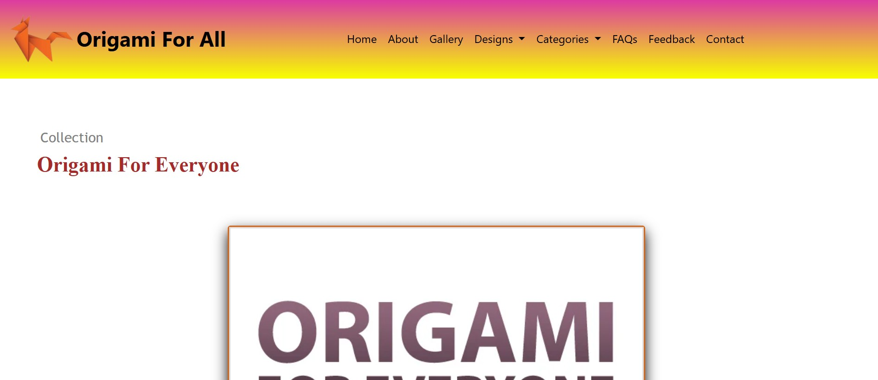

SCREENSHOTS
ABOUT
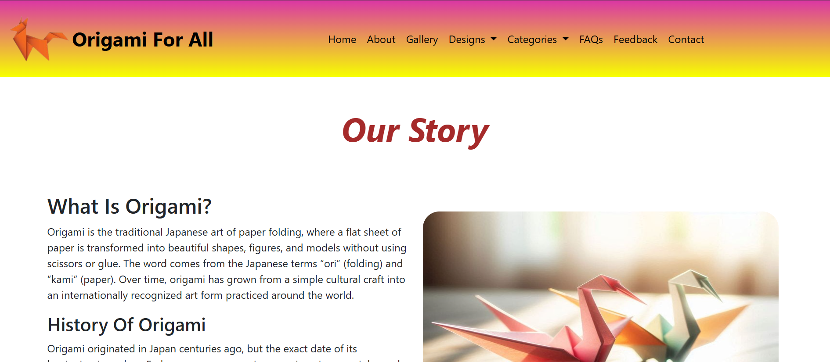

Gallery
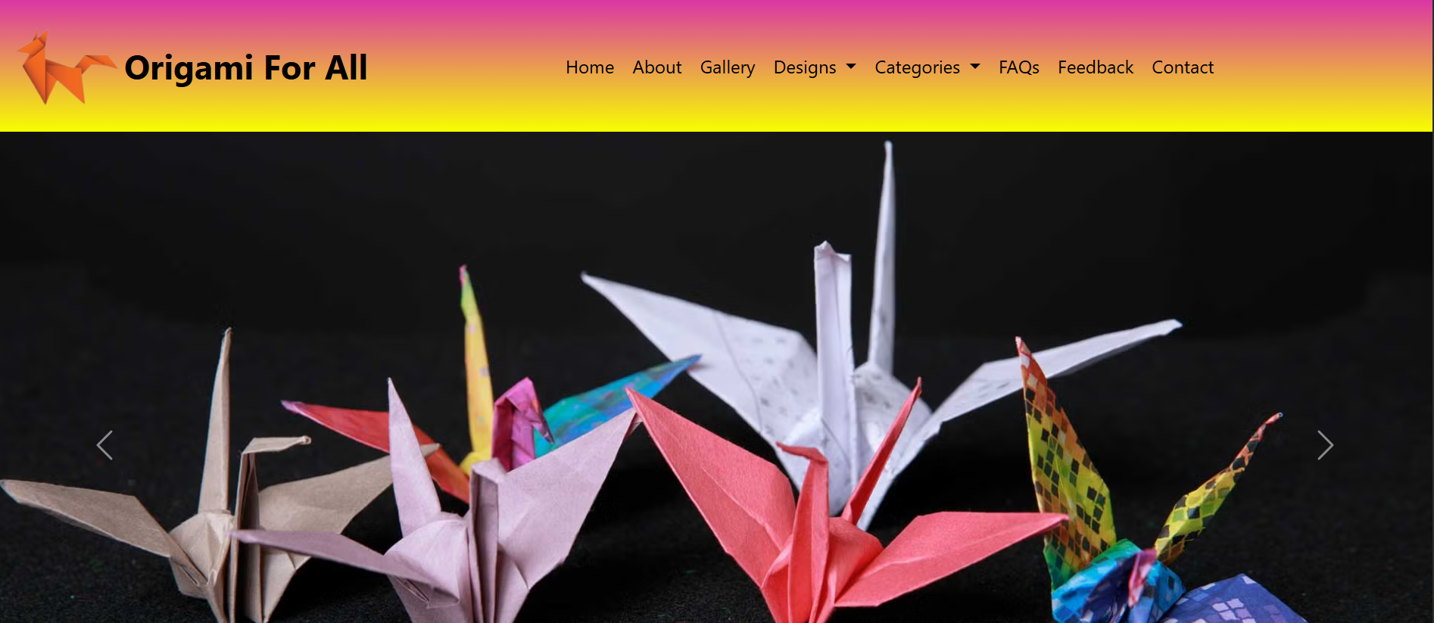
Contact
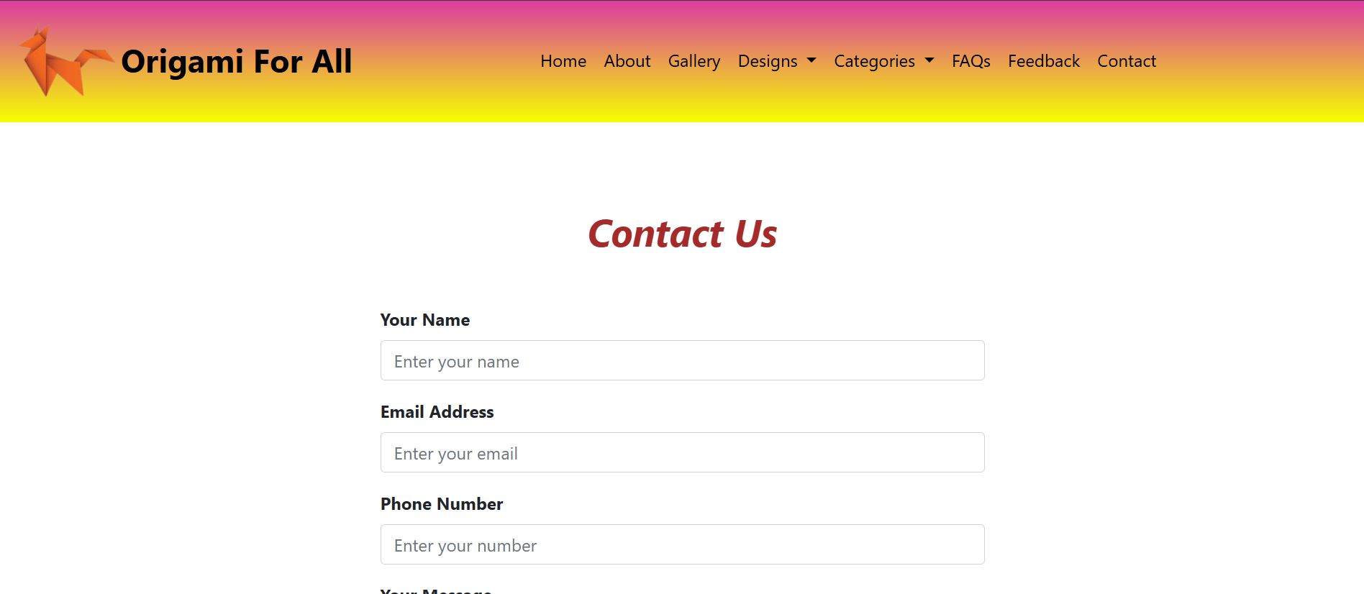

Designs
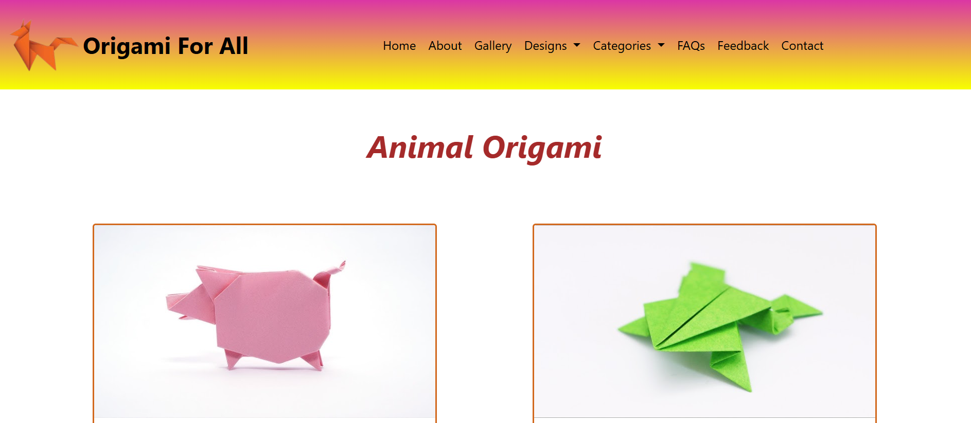

Thank you

